Did you know that physical therapy is a safe and effective treatment option for many women’s health issues, especially during and after pregnancy?
Come Find us
Nevada Physical Therapy is located in the Sports Medicine Center on the University of Nevada, Reno campus, just south of the football stadium. We accept most insurances. Our team will customize an appropriate treatment program based on your specific needs and goals
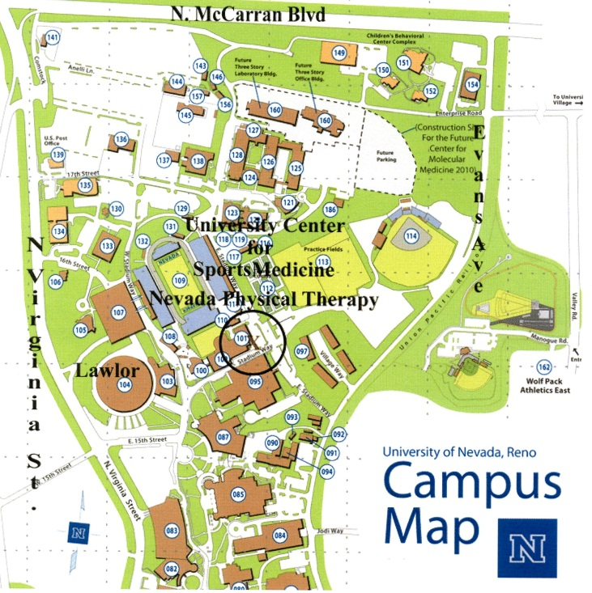
Crista Jacobe-Mann, PT with her daughter, Ellie
- Pregnancy related back and pelvic pain
- Core weakness during and after pregnancy
- Stress urinary incontinence (SUI)
- Diastasis Rectus Abdominus (DRA)
- Postural dysfunction with breastfeeding and caring for your child

“The posture a woman assumes after pregnancy is the posture she will carry with her the rest of her life” ~Diane Lee, PT

Confessions from a PT with “mom” posture
This is me. I am a 35 year old physical therapist pushing my 3 year old daughter at the splash park this summer. I was shocked to really look at my posture from an outside perspective. I have officially assumed the “mom posture”- rounded shoulders, forward tilted pelvis, sway back, and forward head. Even the guy behind me is standing taller and straighter and he doesn’t look too excited to be there!
I have been a PT for 10 years. I’ve spent countless hours educating and helping others and myself move better. Then I became a mother and most of my days since have been spent bent over caring for Ellie.
The female human body is an amazing machine. The uterine muscle increases its capacity by 1000x throughout pregnancy and then goes back to its normal size, sort of. This is where I come in. Since becoming a mother, my PT lens focus has changed a lot. I mostly work in orthopedics and sports medicine. Now that I see the cascade of what happens to a woman’s body during pregnancy and after childbirth and then into late adulthood I feel it is my duty to inform and help women catch and fix changes in their posture early. I have attended conferences and courses regarding women’s health issues and restoring posture. I would love to teach you what I have learned. Umbilical hernias, incontinence and diastasis rectus abdominus are common after pregnancy, and they CAN be treated. You don’t have to just live with it.
So before you try another “core strengthening” video or group class that involves crunching and sit-ups that could potentially make your belly protrude more, consider an evaluation from a Physical Therapist. Call me and we can work on this motherhood thing together!
Contact US

Nevada Physical Therapy 775-784-1999
PO Box 8940 Reno, NV 89507 www.nevpt.com

